Keyword AAA
A Thesaurus of General Terms

State Records Authority of New South Wales
Sydney, Australia
Revised Edition 1998
Reprinted 2000


© State of New South Wales through the State Archives and Records Authority of NSW 2022
This work is licensed under a Creative Commons Attribution + ShareAlike 4.0 International License. To view a copy of this license, visit https://creativecommons.org/licenses/by-sa/4.0/ .

Keyword AAA: A Thesaurus of General Terms
First Published 1995
Reprinted 1997
Revised edition 1998
Reprinted 2000
State Archives and Records Authority of New South Wales
PO Box 516
Kingswood NSW 2747
AUSTRALIA
Telephone: (02) 9673 1788
Email: govrec@records.nsw.gov.au
Website: www.records.nsw.gov.au
ISBN 9780731388165
Table of Contents
1. Introduction 6
Acknowledgments
1.1 Background
1.1.2 Key differences between the GADM Thesaurus and Keyword AAA
1.2 The function-based approach
1.2.1 The business classification scheme
1.2.2 The Keyword Classification System
1.2.3 A sequence of business activities
1.2.4 Overarching functions
1.3 The practical value of Keyword AAA
1.3.1 The practical value of Keyword AAA for electronic documents and records
2. How to Use Keyword AAA 20
2.1 The classification system
2.1.1 Classification
2.1.2 Indexing
2.1.3 Titling
2.1.4 When to create new files
2.1.5 How to classify and index records using the thesaurus
3. Components of Keyword AAA 26
3.1 The Classification Guide
3.1.1 Format of the Classification Guide
3.2 Components of the thesaurus
3.2.1 Keywords
3.2.2 Activity descriptors
3.2.3 Subject descriptors
3.2.4 Free text
3.2.5 Scope notes
3.2.6 Codes
3.2.7 Broader terms (BT)
3.2.8 Narrower terms (NT)
3.2.9 Non-preferred terms
3.2.10 Related terms (RT)
3.2.11 Permitted acronyms
3.2.12 Parenthetical qualifiers
3.2.13 SEE reference
3.2.14 USE reference
3.2.15 Tips
4. Using And Maintaining Keyword AAA In Your Organisation 33
4.1 Using Keyword AAA in your organisation
4.1.1 Functional and merged thesauri
4.1.2 Adapting Keyword AAA for your agencies
4.2 Implementing your merged thesaurus
4.3 Monitoring and quality control
4.4 Thesaurus maintenance
4.5 Upgrading
4.5.1 Decision of implementation strategy 37
- Managing ‘part’ or ‘volume’ files 38
4.5.3 Upgrading to the 1998 version of Keyword AAA 39
5. The 1998 Version of Keyword AAA 41
Appendix 1: Glossary 42
Appendix 2: List of Keywords 47
Appendix 3: List of Activity Descriptors 50
Appendix 4: Permitted Acronyms and Abbreviations 52
Appendix 5: Thesaurus Suggestion Form 53
Appendix 6: Quick Guide to Assigning File Titles Using Keyword AAA - Paper 54
Appendix 7: Quick Guide to Assigning File Titles Using Keyword AAA - Electronic Directory Structures 56
Appendix 8: Frequently Asked Questions 58

1 Introduction

Acknowledgments
The State Records Authority of New South Wales (formerly known as the Archives Authority of New South Wales) would like to extend warm thanks to the many people who provided advice and other assistance in the preparation of Keyword AAA.
Contributions to the 1995 version has been acknowledged in the foreword to that edition.
The first major post-implementation review of Keyword AAA was undertaken in 1997-8. The review process involved distributing questionnaires to all users, then discussing draft changes at user forums held in Sydney, Perth, Hobart, Canberra and Adelaide. The feedback received from users was invaluable as it ensured that the 1998 version is more comprehensive and relevant to our clients. Our thanks to all users who have participated in the review process.
We particularly wish to acknowledge the following people and their contributions to the review process:
Marian Hoy (Assistant Director, Records Control, National Archives of Australia). Marian liaised substantially with the then Archives Authority to ensure that the 1998 version of Keyword AAA was more relevant for Commonwealth users. She also offered us considerable advice and assistance on terminology and conducted a review forum in Canberra. Julie Bright (Recordkeeping Consultant, Records Services Team, Public Records Office of Western Australia), Tina Howard (Senior Records Management Officer, Archives Office of Tasmania) and Peter Acres (Project Director, State Records, South Australia) also deserve our special thanks for conducting review forums in their states and liaising closely with the Authority for the review process.
Kerry Gordon (Consultant, Provenance Consulting Services), Joy Siller and associates (Consultants, Siller Systems Administration), Lyn Castle (Homecare NSW), Ken Bullock and Catherine Hanley (Office of Information Technology) and Robin Parsons (Department of Education and Training, NSW) kindly provided us with substantial advice and assistance on the draft changes. The staff from the Government Recordkeeping Program and Janette Pelosi from Systems at the then Archives Authority of New South Wales deserve our special thanks for their patience, suggestions and proof reading abilities. None of these people bear responsibility for any shortcomings in the 1998 version of Keyword AAA.

1.1 Background
Keyword AAA is a thesaurus of general terms designed for use in classifying, titling and indexing most types of records in most technological environments. It covers terminology common to business functions and activities in most organisations and should be used in conjunction with a thesaurus of functional terms, relating to the organisation’s specific or core business functions, to provide comprehensive controlled vocabulary coverage. See Section 1.2 for more information regarding a functional thesaurus.
Keyword AAA is a logical progression in thesaurus products developed by the State Records Authority of New South Wales (known as 'State Records') over the last 20 years.
The first of these products was a subject-based thesaurus, the Thesaurus of General Administrative Terms, or GADM as it has been better known, which was released in 1978. The GADM Thesaurus became Australia’s most popular and successful government records management thesaurus, and in 1995 was being used by more than 140 public sector organisations at all three levels of government around Australia.
The GADM Thesaurus was regularly revised and Keyword AAA, released in November 1995, is the product of the 1994/1995 revision. The different name reflects the fact that this revision involved a fundamental rethinking and resulted in a new product, rather than just a new version of the old product.

1.1.2 Key differences between the GADM Thesaurus and Keyword AAA
There are a number of significant differences between the GADM Thesaurus and Keyword AAA. The most notable is that Keyword AAA uses a function-based approach to reflect the business context in which records are created, while the GADM Thesaurus classified records according to the subjects they reflected. See Section 1.2 for an explanation of the function-based approach.
In addition, Keyword AAA improves on its predecessor as it features:
- a streamlined look, through the reduction of terms
- redefined scope notes for keywords and activity descriptors
- an imposed hierarchical structure between the first and second levels of descriptors, keywords and the activity descriptors, which was not evident in the GADM Thesaurus, and which encourages users to classify and title in a way that reflects the business functions and activities of their organisation
- a Classification Guide to supplement the thesaurus
- more flexibility in the titling rules and in the way the thesaurus can be used
- an approach that conforms, as much as is practicable, to the structure, codings and layout of the relevant International Standard: ISO 2788-1986(E), Documentation - Guidelines for the establishment and development of monolingual thesauri, and
- an approach that conforms to the Australian Standard AS 4390-1996, Records Management, Part 4, Control, Clause 7.2.
By embracing the functional analysis methodology Keyword AAA aims to provide more than just the vocabulary control offered by the GADM Thesaurus. It aims to provide:
Accuracy of titling and retrieval through classification by keywords
Accessibility through use of common terminology, and
Accountability through better control of records.

1.2 The function-based approach
To understand Keyword AAA, its relationship to the GADM Thesaurus and why State Records undertook to produce such a radically new product, we need to look briefly at the theory of functional analysis and its application to thesauri.
The prime purpose of a thesaurus is to provide control and consistency over the vocabulary used for titling and indexing records. It does so by providing an alphabetical listing of approved terms that, if desired, may be used for titling and indexing. Knowing which terms to search on means that searches will be more efficient and retrieval of the right records is facilitated.
Until recently most thesauri were subject-based. Indeed, when classifying many published materials, subject-based approaches have proved to be quite appropriate. Records managers have also used subject-based thesauri to classify records in traditional paper-based file systems. The GADM Thesaurus is an example of a subject-based thesaurus designed for paper-based records.
In recent years Australian recordkeeping professionals have questioned the applicability of traditional approaches to most records management activities, including classification, particularly with the challenges arising from working in the electronic environment. They have been particularly influenced by their North American counterparts who have espoused the use of functional analysis specifically for the management of electronic records. Functional analysis is the process of analysing functions (or broad areas of business activity) and assessing the need to keep evidence of these functions.
In Australia, the functional approach is embodied in the Australian Standard AS 4390 - 1996, Records Management, where it is applied to all aspects of records management. According to the standard, records are defined as:
recorded information, in any form, including data in computer systems, created or received and maintained by an organisation or person in the transaction of business or the conduct of affairs and kept as evidence of such activity. (Part 1, General, Clause 4.21)
The standard recognises that records are defined by their relationship to the activities that they document. This gives them meaning and context.
The standard defines classification as:
...the process of devising and applying schemes based on the business activities which generate records, whereby they are categorised in systematic and consistent ways to facilitate their capture, retrieval, maintenance and disposal. Classification includes determining document or file naming conventions, user permissions and security restrictions on records.(Part 1, General, Clause 4.8)
It is clear that the standard regards classification as a valuable records management tool that can be used for a variety of different activities. By applying classification schemes based on business functions, records can be indexed and titled and we can determine how they should be kept, how they should be stored and who should have access to them.
Thus classification assists a comprehensive and long-term approach to the management of records. Section 1.3 explains the benefits of this approach further.

1.2.1 The business classification scheme
Keyword AAA is based on the business classification scheme advocated in The Australian Standard AS 4390 - 1996, Part 4: Control.
As the standard states, business classification schemes are derived from an analysis of an organisation’s business processes. The analysis focuses on:
- the goals and strategies of the organisation
- the broad functions and activities of the organisation which support the pursuit of the goals and strategies
- the activities of the organisation which constitute the accomplishment of the functions, and
- the groups of recurring transactions which constitute each activity. (Part 4, Control, Clause 7.2)
Business classification schemes are not based on organisational structure as:
- functions and activities are more stable than administrative structure which are often amalgamated, devolved, decentralised or restructured regularly, and
- functions and activities can be distributed among structural components of the organisation. For example, an agency may have a Finance Branch but other business units will also be required to carry out some financial activities so tying the classification scheme down to the structure of the Finance Branch does not accommodate the way that business really works. Functions and activities often cut across the structure of an organisation. (Australian Standard AS 4390 - 1996, Records Management, Part 4, Control, Clause 7.2)
The Standard recommends that a business classification scheme be hierarchical, with the top level representing broad business functions, the second level representing the activities constituting those functions and the third and subsequent levels representing the groups of recurring transactions that take place within these activities.
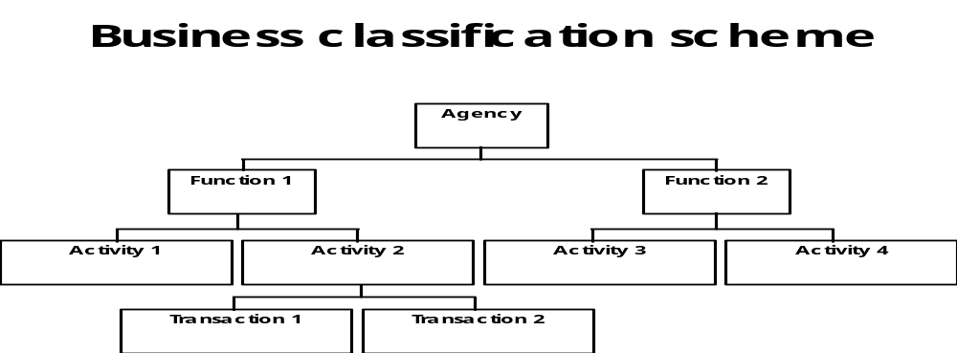
The scheme moves from the broad to the very specific.

1.2.2 The Keyword Classification System
See Section 2.1.1 for an explanation of classification.
With the Keyword Classification System, descriptors are assigned to each of the levels in the hierarchy described in Section 1.2.1.
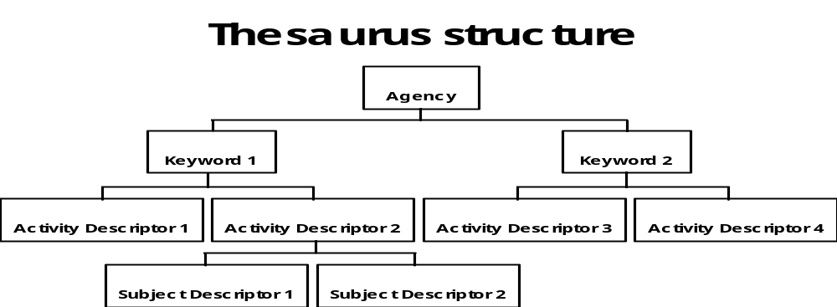
According to our classification model:
- keywords represent broad business functions of an agency
- activity descriptors describe the more specific activities taking place within those functions, and
- subject descriptors are added as a means of describing the more specific subjects or topics relating to the matter to be documented within an activity.
The keywords and descriptors are the authorised terms provided by the thesaurus.
- These authorised terms can be supplemented by some free text, that is, words not derived from the thesaurus, such as the name of an organisation, an individual or a project.
Thus a file title is constructed by allocating a keyword, followed by an activity descriptor, followed by a subject descriptor and/or some free text.
Note: Within Keyword AAA, the keyword always takes first place in a title, followed by an activity descriptor. These two levels are compulsory but there is more flexibility at subsequent levels. See Sections 3.2.1-3.2.4 for more information. This order is imposed to ensure that the business activity being documented is shown, in context, through the file title. For example:
PROPERTY MANAGEMENT - MAINTENANCE - Lifts*
*In Keyword AAA keywords and activity descriptors are presented in upper case, subject descriptors in mixed lower case and free text in italics in order to distinguish the hierarchy. Some of these conventions cannot be shown in records management software.
In the example, PROPERTY MANAGEMENT is the keyword in Keyword AAA to describe the function of managing agency premises. MAINTENANCE is the activity descriptor representing this activity taking place. Lifts is the subject descriptor, showing the subject/topic being documented on the file. You can see from the file title itself that lifts are one concern when carrying out the maintenance activity and that maintenance is an activity that must take place when managing premises.
The keyword and descriptors can be used as index terms to index the file, along with free text words you add. Modern records management software products are designed to index automatically on terms allocated to a title drawn from a thesaurus. See Section 2.1.2 for more information about indexing.

1.2.3 A sequence of business activities
When classifying using the Keyword Classification System you may need to create more files than you have previously, although some users have reported a reduction in files created as subject-based files often comprise a number of parts (this is dependent on individual agency needs and circumstances).
For example, what may have been one subject file called Records Management System may, under keyword classification become:
TECHNOLOGY AND TELECOMMUNICATIONS - EVALUATION - Records Management System
This file will document the activities concerned with the assessment of various records management systems in order to reach a decision regarding which one to purchase.
TECHNOLOGY AND TELECOMMUNICATIONS - ACQUISITION - Records Management System
This file will be concerned with the acquisition of the records management system chosen.
TECHNOLOGY AND TELECOMMUNICATIONS - INSTALLATION - Records Management System
This file will document the installation of the system in the organisation.
TECHNOLOGY AND TELECOMMUNICATIONS - MAINTENANCE - Records Management System
This file will document the maintenance of the system required.
TECHNOLOGY AND TELECOMMUNICATIONS - REVIEWING - Records Management System
This file will document reviews undertaken to assess the performance of the system and whether it has met expectations.
These files are, of course, related and their relationship should be indicated. For example, you would note the file numbers of related files on the file cover or in the records management software.
If the files are expected to be small, as a result of breaking them up into activities, you might like to consider broadening the file. For example, you might use only the first two levels, and document other technological equipment on the same file.
The documentation of separate activities as shown above will assist in the long term management, storage and disposal of records, saving your organisation time and money. See Section 1.3.

1.2.4 Overarching functions
When compiling the keywords for Keyword AAA our intention was that each keyword would represent a broad administrative function. However some functions are so large and encompass so many different activities that they would not be meaningful when applied to file titles.
HUMAN RESOURCES is an example of a large function carried out in most organisations. Human Resource Management includes activities such as establishing positions, development of staff, approval and processing of leave, Occupational Health and Safety matters, industrial relations and more.
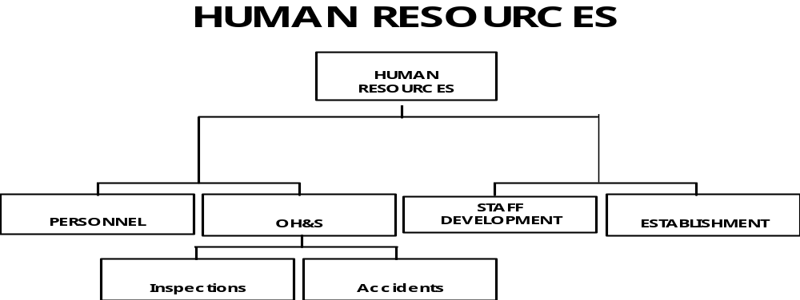
To apply this in a hierarchical fashion to a file title would mean that Human Resources would be the first level of the hierarchy, Occupational Health and Safety on the second and the inspection of premises for workplace hazards would appear on the last level.
A file title using this hierarchy would appear as:
HUMAN RESOURCES - OCCUPATIONAL HEALTH AND SAFETY - Inspections.
This is a rather clumsy title and the activity taking place, the inspection of the workplace, is classified at the subject level rather than the activity level. Besides, OCCUPATIONAL HEALTH AND SAFETY is not an activity: its the sum of many activities.
Consequently we opted not to use the first level term HUMAN RESOURCES, but rather chose the next level for the function/keyword. As a result, the terms PERSONNEL, OCCUPATIONAL HEALTH & SAFETY, STAFF DEVELOPMENT and COMPENSATION appear as keywords in Keyword AAA.
Another example of an ‘overarching function’ is the function of INFORMATION MANAGEMENT AND TECHNOLOGY. This was considered too large for the first level of the hierarchy. Instead INFORMATION MANAGEMENT and TECHNOLOGY AND TELECOMMUNICATIONS were the keywords chosen.
Please note: The size of your organisation will dictate whether the level of functions we have chosen is appropriate for you or whether some customisation is needed. See Section 4.

1.3 The practical value of Keyword AAA
So in practice, what are the advantages of Keyword AAA, a function-based thesaurus, over subject-based thesauri like the GADM Thesaurus?
Firstly, and most importantly, as Keyword AAA is a product of a business classification scheme it can be used for a number of important records management functions. The analysis and classification can assist you to determine:
- how long a record should be kept
- how it should be handled and stored, and
- who should have access to it.
For example, using activity descriptors such as POLICY, COMPLIANCE and SECURITY, immediately identify a record as having particular qualities which would require specific handling.
The use of the activity descriptor POLICY would immediately tell you that the file was probably significant to the agency. Even before checking the relevant records disposal schedule, this activity descriptor should alert you to the fact that the file is likely to require long term retention. Therefore, if creating a paper-based POLICY file you might consider using permanent paper to ensure it survives for the period it is required. If it is an electronic record, you might need to earmark it for migration to new platforms when you upgrade your software and hardware to ensure it can still be read in the future.
In New South Wales, no public record can be destroyed without the permission of State Records. Other states and the Commonwealth have similar authorities which must be consulted before records are destroyed. State Records has developed a number of General Records Disposal Schedules to enable the application of standard disposal actions.
The General Records Disposal Schedule - Administrative Records (1996) is based on a similar classification scheme as that used in the first edition of Keyword AAA. Some examples from the Schedule are shown on the following pages. Like Keyword AAA, the Schedule has a hierarchical structure consisting of three levels. These are:
- Function: Functions are the top level terms used in the schedule and most of these are also keywords in Keyword AAA.
- Activity: Each function is divided into activities. Most of the activities listed in the Schedule are also activity descriptors in Keyword AAA.
- Disposal class: Disposal classes are listed under each activity. Disposal classes are ‘classes of records performing or recording similar activities and therefore having the same retention period and disposal action.’ (AS 4390, Part 1, General, Clause 4.11).
Functions and activities describe business activity but disposal classes describe categories of records. It is also only at the disposal class level that specific values, in the form of retention periods and disposal decisions, are attached to particular categories of records.
The value of using similar classification schemes in the thesaurus and the Schedule becomes clear when sentencing files. In many cases, where there is only one disposal class attached to a particular function and activity in the Schedule, files should be able to be sentenced at creation, since there is only one possible disposal action that could be applied. The extract from the General Records Disposal Schedule - Administrative Records showing PUBLICATION - PRODUCTION (shown on page 15) is an example of this type of entry. All files having this title should be retained for one year after action on the file is completed, and then destroyed.
However, sometimes files with similar titles may require different disposal actions. FINANCIAL MANAGEMENT - TREASURY MANAGEMENT (shown on page 16) is an example of this type of entry. Sentencing in these circumstances will require more analysis and it may not be possible to sentence at creation, since there is more than one disposal class under this function and activity.
This is particularly true if the disposal class is determined by a factor that cannot be shown through the file title. For example, it may be impossible to determine at the point of creation which disposal class applies to a file relating to LITIGATION (shown on page 17). The factors determining which disposal class the file falls under may not become clear until the litigation has been finalised. However, there are few entries of this nature in the General Records Disposal Schedule - Administrative Records.
It is possible, even with carefully controlled use of Keyword AAA, that occasionally a file may end up containing documents falling into more than one disposal class. Files should never be divided up into sections according to different disposal actions, nor should they be ‘stripped’ of some documents. The whole file should be disposed of at the same time. In order to determine the disposal action for such files, the following should always be followed:
- a longer retention period always overrides a shorted retention period
- a requirement to retain a record as an archive always overrides an authorisation for destruction.
Obviously, the use of similar classification schemes in functional thesauri and functional records disposal schedules can also be extremely useful and will result in similar efficiencies in the management and disposal of functional records. Check with your relevant archival authority for more information and requirements. See Section 4.1.1 regarding the compilation of a functional thesaurus.

No | Function/Activity | Description | Archives Authority Decision | Disposal Action | Requirements/Remarks
PUBLICATION
(Continued)
24.11.0 | Production
24.11.1 |  | Records relating to the production of agency publications, including design, layout, typesetting, desktop publishing, printing, binding, etc. | NSA | Destroy 1 year after action completed

No | Function/Activity | Description | Archives Authority Decision | Disposal Action | Requirements/Remarks
FINANCIAL MANAGEMENT
(Continued)
12.18.0 | Tendering | See  7.7.0 - CONTRACTING-OUT
12.19.0 | Treasury Management | The process of the general conduct and efficient and economical management of the funds of the organisation by ensuring an effective system of internal control is in operation. Includes investments and loans.  (From Keyword AAA)
12.19.1 |  | Records relating to the agency’s overall Treasury Management strategy | SA | Transfer as State archives 10 years after action completed
12.19.2 |  | Records relating to operations and individual appropriations, investments and loans | NSA | Destroy 5 years after action completed

No |  | Function/Activity |  | Description | Archives Authority Decision | Disposal Action |  | Requirements/Remarks
LEGAL MATTERS
(Continued)
19.2.0 | Litigation
19.2.1 |  |  | Records dealing with issues, claims or cases matters:  - of major public interest or controversy;  - which are precedent-setting in nature; or  - resulting in significant changes to the agency’s policy and/or procedures. |  | SA |  | Transfer as State archives 15 years after action completed
19.2.2 |  |  | Records relating to other litigation |  | NSA |  | Destroy 15 years after action completed or upon expiry of statute of limitations, whichever is longer
19.2.3 |  |  | Subpoenas and discovery orders |  | NSA |  | Destroy 2 years after action completed

1.3.1 The practical value of Keyword AAA for electronic documents and records
Another advantage of Keyword AAA is that it can be applied to electronic documents and records as well as paper-based files. One way this can be achieved is by constructing directory structures with Keyword AAA titles. The following is an example of the way Keyword AAA is used in directory structures at State Records:
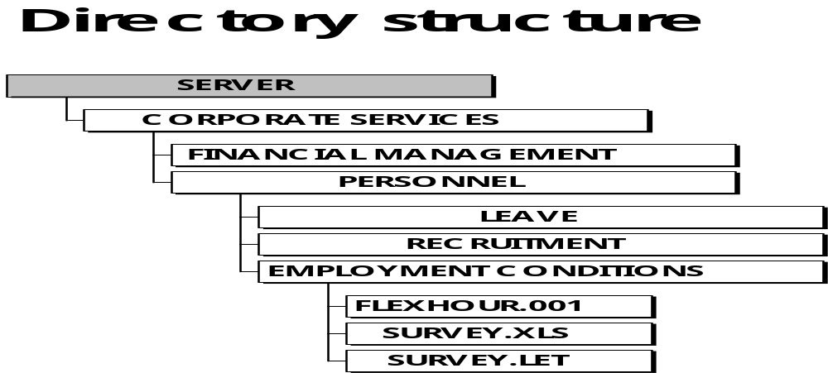
In the diagram, the workgroup is Corporate Services. Within that group you can open one of a series of folders which are titled by keywords from Keyword AAA. For example PERSONNEL is a keyword likely to be used by Corporate Services staff as they carry out personnel functions. Once open, the PERSONNEL folder contains another series of folders titled by activity descriptors, such as RECRUITMENT, which represent the activity level. Open one of these folders, and you are brought to the level of individual documents such as spreadsheets and word processing documents, described either by subject descriptors from Keyword AAA or by free text.
What this means, is that staff who share documents do not have to search through a variety of idiosyncratically titled electronic documents to find the one that they or their colleagues have been working on. Rather, they can follow the logical path to the document using the thesaurus. Directory structures incorporating Keyword AAA terminology can be used to manage work processing files, e-mails, spreadsheets, graphics and images.
Documents that are also records, and are managed by document management software, can also be assigned keyword titles and linked to the relevant electronic or paper files.
The advantages of using Keyword AAA for the classification of electronic documents as well as paper filing systems can be summarised as follows:
- the documents are tied to the goals and objectives of the organisation
- the efficiency and rapidity of retrieval is improved
- good recordkeeping is supported by showing the difference between electronic records and other information resources
- electronic documents that function as records can be linked to the records management system by using the same classification scheme and/or linking through the file number
- consistent practices and procedures are promoted, which facilitates the use of the corporate information resources and systems by staff
- keywords (that is, broad functions) and activities can be used to appraise broad series of documents
- icons can be designed to link users to applications built around specific functions that are of use to them
- the classification scheme can be used as a basis for metadata (data about data). For example, scope notes give you more information about the record being classified. The thesaurus itself provides a form of system documentation by describing how records are classified in the recordkeeping system and documents can be linked to these.
2 How to Use Keyword AAA

2.1 The classification system

2.1.1 Classification
Classification involves developing thesauri and similar tools and applying them in the titling and indexing of records. By developing controlled language systems, consistent language in titling and indexing is ensured.
Classification allows like or similar aspects of a function to be drawn together in a systematic and consistent way to enable the effective and accurate identification and retrieval of records from recordkeeping systems. For example:
PUBLICATION - DRAFTING - For the Record
In the above example, all drafting activities for the publication For the Record are systematically placed on the one file, or all the electronic documents related to this one activity can be kept together in one folder.
A sequence of business activity may be followed using a group of records that have been classified together.
PUBLICATION - PLANNING - For the Record
PUBLICATION - RESEARCH - For the Record
PUBLICATION - DRAFTING - For the Record
PUBLICATION - PRODUCTION - For the Record
PUBLICATION - DISTRIBUTION - For the Record
PUBLICATION - REVIEWING - For the Record
See Section 1.2.3 for more information on the sequence of business activities. See Section 1.3 for the benefits of segregating files according to different activities.
Classification schemes are normally hierarchical in nature, with a tree-like structure moving from the broadest to narrowest aspect. For example:
COMMUNITY RELATIONS - MARKETING - Presentation Packages
(broadest term) (narrower term) (even narrower term)
In keyword classification files are classified into broad functionally-based areas (represented by keywords) and further defined by activity descriptors and subject descriptors arranged in the hierarchical order.

2.1.2 Indexing
Indexing involves attaching one or more searchable terms (or labels) to each record item, such as a file, or a paper or electronic document. Each label is called an indexing term. Successful indexing depends on the use of indexing terms drawn from the controlled vocabulary developed in the classification process.
Classification and indexing are related but distinct processes, used together, to establish intellectual control over records. Terms from the classification scheme are often assigned as indexing terms. Retrieval is simplified and made more accurate by limiting the range of permissible indexing terms through the use of controlled vocabulary (for example, a thesaurus). All files on one function or activity can also be grouped together in the index.
An index is a retrieval device. It is a separate tool to a thesaurus and is not an index to the thesaurus. You cannot classify a document with an index.
The most common type of index is a list of file titles arranged alphabetically linked to file numbers. It can be kept in different formats, for example, on cards or on records management software.

2.1.3 Titling
Records document transactions. In file-based systems, either paper or electronic, a file should bring together the documentation of a sequence of transactions making up an activity, process or project.
The title given to a record, whether at the document or file level, should embody the limits of the transactions or action, embody its hierarchical classification, and place it in its functional context within the organisation.
Thus titles should be representative of the record's context as well as its content.

2.1.4 When to create new files
In file-based systems, a new file should be created when a document cannot be filed appropriately on existing files because:
- it initiates a new function, activity or sequence of transactions
- a new aspect or phase of the function or project has emerged
- the previous file has been closed because it is too old to remain open (in many file-based systems, a file is automatically closed when it is five years old and a new volume is created)
- a new volume of the existing file is needed for convenient physical handling
- the existing file's action and papers have been reviewed and a new title is considered appropriate.

2.1.5 How to classify and index records using the thesaurus
Classification requires an understanding of the context and content of the record and a knowledge of existing records in the system.
The process includes the following steps. For more detailed guidance on each of the levels of descriptors see Section 3.2.1 - 3.2.4. Appendix 6 and 7 are flow charts of these steps and can be removed and used by classifiers.

a. Steps in classifying for paper-based filing systems
- Read the document, record or correspondence to be classified.
- Identify the broad business function (broad area of business activity) that it documents. The broad business functions of an agency are described by the keywords in your merged thesaurus so study these to find the best keyword. Reading the scope notes (definitions) for the keywords will help you choose.
- A list of the general keywords in Keyword AAA can be found at Appendix 2 in the hard copy along with scope notes defining their meaning.
- Once you have chosen a keyword, go to that entry in the thesaurus. It will show a list of narrower terms (activity descriptors). You need to choose one of the activity descriptors listed there that best describes the activity to be documented on the file. Make sure you read the scope notes for the alternatives very carefully.
If you have difficulty choosing, ask yourself ‘what is the primary activity to be documented on the file?’, and choose that activity descriptor for the title.
Tip: It may be that you need to create more than one file under keyword classification. For example, what would have been a subject file for the publication of a newsletter is now 5 files as each activity is separately documented:
PUBLICATION - RESEARCH - Newsletter Title
PUBLICATION - DRAFTING - Newsletter Title
PUBLICATION - PRODUCTION - Newsletter Title
PUBLICATION - DISTRIBUTION - Newsletter Title
PUBLICATION - REVIEWING - Newsletter Title
Segregating activities will mean that the files can be managed more appropriately for storage, access, and disposal.
Now you have the first two levels of your hierarchy: the keyword followed by the activity descriptor. These two levels are essential.
- The third level of the file title is more flexible.
You do not need to classify down to the third level if the first two are adequate for retrieval.
If you want to classify further, add the most appropriate subject descriptor to describe the subject or type of transaction documented by the record. Occasionally more than one subject descriptor will be required.
If you cannot find an appropriate subject descriptor you can insert your own free text. You can also add free text in addition to a subject descriptor if you need further specification. Remember to use free text terms like names of organisations and individuals as these are likely access points for retrieval. You may need to establish conventions for names. For example:
Do you use:
John Smith
Smith John
Smith J. or
J Smith?
The important points to remember are:
- think carefully about what exactly is to be documented on the file
- think carefully about your agency’s needs
- only classify as much as you need to retrieve, and
- use terms that are likely access points for retrieval.
For example:
PERSONNEL - RECRUITMENT (keyword and activity descriptor)
This is a very broad title and allows you to put anything about recruitment on it. However, it may be too broad if recruitment is a common practice in your agency.
PERSONNEL - RECRUITMENT - Applications (keyword, activity descriptor, subject descriptor)
This file title will allow you to place only applications for recruitment for all positions in the organisation on the file. Would this be a useful distinction for your agency or not?
PERSONNEL - RECRUITMENT - Applications - Records Manager (keyword, activity descriptor, subject descriptor, free text)
This file title is more specific again, allowing only applications for the position of Records Manager to be placed on the file. Would this be a useful distinction for your agency or not?
PERSONNEL - RECRUITMENT - Records Manager (keyword, activity descriptor, free text)
This file title is less specific than the previous example, as you can document everything to do with the recruitment of a records manager, not just applications. Would this be a useful distinction for your agency? People would probably be likely to search on the position to try and retrieve the file.
- Arrange all the elements in hierarchical order: a keyword, followed by an activity descriptor, followed by a subject descriptor and/or free text. This is your title.
- Search your file index to check for an existing file featuring the same or a similar title to what you have devised. If a file exists, attach the correspondence to that file. If no appropriate file exists, create a new file. Index on the terms and free text used in the title (if you have a records management software package this will happen automatically).

b. Using Keyword AAA for organising electronic directories
Please note: This is merely a suggested means of classifying electronic documents within directory structures. Different organisations have different procedures in place regarding the classification of electronic documents so check with the organisation first before applying these steps.
In this case, we are using terms from Keyword AAA and the organisation’s functional thesaurus to name directories and folders. These instructions will apply once the directory paths have been established.
- Follow the steps 1-4 described above to identify your file title.
- To save your electronic document, open the directory containing the workgroups and click on the appropriate workgroup.
- You will be presented with a list of keywords. Click on the folder for the appropriate keyword.
- You will be presented with a list of activity descriptors. Click on the folder for the most appropriate activity descriptor.
- You will now be at the subject descriptor level. What you do at this level is determined by how much you wish to classify your document.
i. Subject descriptor and free text
If you wish to use a subject descriptor and free text, check to see if there is a subject descriptor folder already which is appropriate for your title.
If so, click on it. At the next level (the free text level) check to see if there is a saved document already in existence using the free text title that you have identified. If there is, you may need to call your document something different to distinguish it (see advice below). If not, name your document using the free text title and save it.
If there is no subject descriptor folder that is suitable, you will need to create one, open it, and name your document using free text.
ii. Subject descriptor only
If you wish to wish to use just a subject descriptor, check to see if there is a saved document already in existence using the subject descriptor you have identified.
If so, you may need to call your document something different to distinguish it (see advice below).
If not, name your document using the subject descriptor and save it.
iii. Free text only
If you wish to use just free text at the third level, check to see if there is a saved document already in existence using the free text title you have identified.
If so, you may need to call your document something different to distinguish it (see advice below).
If not, name your document using the free text title and save it.
Document naming
It is recommended that title structures follow a standardised format and order. This will depend on the software you have and the procedures of your organisation.
If you are working in a Windows environment where you are not limited to 8 characters, we suggest that you use conventions such as document type; subject; and unique identifier.
- The document type specifies whether it is a memo, facsimile or e-mail etc.
- the subject reflects what the document is about, and
- the unique identifier reflects information that allows you to uniquely identify that document (for example, what version it is, or some other distinguishing feature).
For example a document may be titled:
Memo re State records legislation 001
(document type) (subject) (unique identifier)
The identifier distinguishes different memos relating to the same subject.
If you would like more information on titling documents and directories in any software environment, please obtain a copy of State Records' publication Desktop Management: Guidelines for managing electronic documents and directories.
3 Components of Keyword AAA

3.1 The Classification Guide
The Classification Guide is provided as a short cut for users who are familiar with the thesaurus terms and their meanings. The guide can be used quickly to select a keyword and its narrower terms. It is hierarchical, reflecting the classification scheme on which the thesaurus is based.

3.1.1 Format of the Classification Guide
The Classification Guide has a three column format:
Column 1: keyword
Column 2: activity descriptors associated with that keyword
Column 3: subject descriptors associated with the activity descriptors listed.
Please do not use the Classification Guide unless you are thoroughly familiar with the scopes of terms in the thesaurus.

3.2 Components of the thesaurus

3.2.1 Keywords
Keywords (KW) are identified in hard copy versions of Keyword AAA in large UPPER CASE with the word keyword at the end of the term line. Scope note and narrower terms are listed below each entry. Keywords must always be the first element in a file title.
Keywords are linked to activity descriptors and, in the software they appear as broader terms to activity descriptors. You can only use those activity descriptors that are listed under the keyword in the thesaurus and Classification Guide.

3.2.2 Activity descriptors
Activity descriptors are identified in hard copy versions of Keyword AAA by UPPER CASE with the word activity descriptor at the end of the term line. They appear as narrower terms of keywords and broader terms of subject descriptors in the software. The activity descriptor reflects the activities performed within the function that is represented by the keyword.
A keyword is followed by one activity descriptor (AD). You can only use those activity descriptors that are listed under the keyword in the thesaurus and Classification Guide.
When registering file names on records management software, often only one activity descriptor may be entered. Even if this can be overcome, we recommend that the amount of activity descriptors on a file should be limited as some activities will have differing retention periods. If you are having difficulty in choosing between two activity descriptors, the general rule is to consider ‘What activity are we primarily documenting?’ The primary activity should be chosen as your descriptor. For example:
If you are documenting a meeting regarding risk management strategies for a particular area of the organisation, appropriate descriptors might be: MEETINGS or RISK MANAGEMENT.
However, the primary activity to be documented on the file is RISK MANAGEMENT so it would be used in the file title.

3.2.3 Subject descriptors
Subject descriptors are identified in hard copy versions of Keyword AAA by Mixed Lower Case with the words subject descriptor at the end of the term line. Subject descriptors are narrower terms of activity descriptors and further define the subject content of the activities.
Terms that describe the subject of the activity descriptor are listed in the Classification Guide. They are also included in the alphabetical listing in the body of the thesaurus.
The subject descriptors listed are the ones most likely to be associated with activity descriptors they are linked to. However, subject descriptors can be free floating, that is, they can be used with any activity descriptor deemed appropriate, not just those they are linked to. In addition, more than one subject descriptor can be added to a file title if desired.
The subject descriptors listed are not comprehensive and are offered as a guide only. Adding all subjects that could be contemplated in government, and all their non preferred terms, would make the thesaurus too large to be useable. We also made a deliberate decision to exclude types of items, processes, leave, employment etc because the lists would be endless. For example:
We have included Discrimination as a subject descriptor, but the types of discrimination (racial discrimination, sexual discrimination etc.) have not been included.
If subject descriptors are insufficient, your organisation might consider adding its own subject descriptors, or free text may be used additionally or alternatively as is appropriate. For example:
We have not included types of equipment and stores. However, your agency may wish to add Photocopiers as a subject descriptor to its merged thesaurus or you could add it to a title as free text. Eg. EQUIPMENT & STORES - ACQUISITION - Photocopiers.
See Section 3.2.4 for more information regarding free text. See Section 4.1.2 for more information regarding customising the thesaurus for your agency’s needs.

Subject descriptors: inverting terms
It is not absolutely necessary to invert the descriptors (as was previously done in GADM). Therefore a file on misappropriated cheques could be either a free text title or an inverted title depending on your conventions. For example:
FINANCIAL MANAGEMENT - ACCOUNTING - Misappropriated Cheques
(keyword) (activity descriptor) (free text)
or
FINANCIAL MANAGEMENT - ACCOUNTING - Cheques - Misappropriated
(type of cheque)
(keyword) (activity descriptor) (subject descriptor) (free text)
Decisions on whether to invert or not is entirely up to the classifier. However whatever choice is made, should be made consistently.

Subject descriptors: top terms
In the initial version of Keyword AAA top terms were occasionally used to help users navigate the hierarchy faster. Top terms were listed under subject descriptors and indicated the most likely keyword associated with that subject descriptor. Top terms have been removed from the 1998 version of Keyword AAA because they caused confusion for some users.

3.2.4 Free text
Free text terms are not listed in the thesaurus.
Free text cannot be used to replace either keywords or activity descriptors. However, it can be used instead of or in addition to subject descriptors.
Generally, free text includes names, words, actions or dates. For example:
PROPERTY MANAGEMENT - MAINTENANCE - Pest Control - City Office
PROPERTY MAINTENANCE - MAINTENANCE - Pest Control - Kingswood Office
The types of names which may be used for this purpose are principally names of organisations, individuals, projects, programs, and courses.
The following are basic rules to follow when using names.

Names of organisations
Use the normal business name of the organisation in full. This can usually be identified from such sources as the organisation's letterhead, invoices or purchase orders. This is important for retrieval, especially in computerised systems, where a user should be able to search successfully on any word in the organisation's name.
Use common or well known acronyms (such as CSIRO) or abbreviations (such as Austel) only as an adjunct to the organisation's full name. This will provide a useful alternative means of retrieval. Never use an acronym or abbreviation instead of the full business name (except in the case of permitted acronyms and abbreviations). See Section 3.2.11.
It is preferable to use the business name with the words in their natural order (thus, Department of Silly Walks, rather than Silly Walks, Department of). This is possible in computerised systems which support free text searching. In manual or less flexible systems, it may be necessary to adopt rules which place the operative words in a name (Silly in this example) at the start, to ensure that it is useful in an index or report based on titles.

Names of individuals
Use the individual's first name (or initial if the first name is unavailable) and surname as used by the individual himself or herself. Use other given names or their initials only when necessary to distinguish individuals with the same first name and surname. Use the individual's title or rank, (such as Dr, Rev[erend], Capt[ain]) only if it is relevant to your business purpose.
Again it is preferable to be able to use the individual's name with the words in their natural order (thus Dr Hugo Thudbucket, rather than Thudbucket, Hugo, Dr). Again, in manual or less flexible systems, it may be necessary to adopt rules which place the surname at the start.

Other uses of free text
When using free text remember that it should ideally be short and concise. It is often these elements that people will recall when they wish to search for a file so choose terms that will aid retrieval.
Administrators should consider whether their agencies require additional terms to be added to their merged thesauri at the subject descriptor level to prevent staff assigning inadequate free text terms that may adversely affect retrieval. See Section 4.1.2 for more information regarding customising the thesaurus.
When assigning free text you should be careful that the title you assign is not too specific (that is, classified too much for your needs).
Remember: the key to classification is to only classify as much as you need to retrieve.

3.2.5 Scope notes
Scope notes provide unique definitions of terms and directions on how to use them. They provide a consistent approach and discourage personal interpretations of the same term by different people across the organisation.

3.2.6 Codes
Keyword AAA conforms, as much as is practicable, to the relevant conventions suggested in ISO 2788 - 1986(E), Documentation - Guidelines for the establishment and development of monolingual thesauri. However, in this thesaurus we used the full term of the code abbreviations used in the standard to ensure that users who are not familiar with library conventions will understand the codes used. For example, we use Broader Term rather than BT.

3.2.7 Broader terms (BT)
Broader terms are concepts having wider meanings. In Keyword AAA, keywords are broader terms than activity descriptors, and activity descriptors are broader terms than subject descriptors.

3.2.8 Narrower terms (NT)
Narrower terms are concepts having more specific meanings. Narrower terms break down a broader concept to more specific aspects of that concept. In Keyword AAA activity descriptors are narrower terms to keywords and subject descriptors are narrower terms to activity descriptors.
Keywords and activity descriptors have a scope note and narrower terms listed below each entry.

3.2.9 Non-preferred terms
Non-preferred terms are identified in the hard copy of Keyword AAA by italics (except when listed under a term) with the word non-preferred term at the end of the term line. They are synonyms replaced by authorised or preferred terms. The USE reference indicates the preferred term. Non-preferred terms were formerly called forbidden terms. For example:
Grading non-preferred term
USE Classification

3.2.10 Related terms (RT)
Related terms bear a close relationship in meaning to the other terms. Related subject descriptors may be used additionally to subject descriptors already selected. Alternatively, the scope notes of related terms may be read to see if they are a more accurate keyword or descriptor to use. For example:
Economic Appraisal subject descriptor
Related Term
Cost Benefit Analysis

3.2.11 Permitted acronyms
Acronyms are pronounceable names made from a series of initial letters or parts of words. For example, UNESCO is the acronym for the United Nations Educational, Scientific and Cultural Organisation. Abbreviations are shortened or contracted words such as NSW for New South Wales.
In Keyword AAA acronyms and abbreviations are generally non-preferred terms. The full term should be used. This is because acronyms and abbreviations change at a rapid pace. More importantly their meaning is obscured to all but those ‘in the know.’ They can be alienating for those not aware of their meaning and may ultimately be meaningless in reflecting the content and context of the record in the file title.
In cases where the acronym or abbreviation has become widely recognised, for example LAN or WAN, the acronym may be used. These are identified in the thesaurus with permitted acronym at the end of the scope note.
Appendix 4 contains a list of permitted acronyms and abbreviations. In merged thesauri an agency can add their own permitted acronyms and abbreviations. See Section 4.1.1 for an explanation of merged thesauri.
When an acronym is not permitted, it may be added to the end of the full version of the term (in brackets) to facilitate searching. For example:
Independent Commission Against Corruption (ICAC)

3.2.12 Parenthetical qualifiers
Parenthetical qualifiers are used to qualify or specify the context of an entry in order to remove ambiguity. In the case of homographs (example below) only one term is a preferred term, the other(s) are non-preferred terms, distinguished by the USE reference directing the user to a preferred term. For example:
Agreements (bonds)
Use Bonds
Agreements (contracts)
Use Contracts
AGREEMENTS
Processes associated with the establishment, maintenance, review and negotiation of agreements.
Here the last example is the preferred meaning for AGREEMENTS in this thesaurus.

3.2.13 SEE reference
In Keyword AAA, several terms have the word ‘SEE’ written at the end of the term line. These terms are to direct users to other terms in the thesaurus or to sources outside the scope of the thesaurus. For example:
Personal Files SEE
See the Personnel Handbook for directions on the creation, maintenance, security and disposal of personal files.
See references within scope notes are there to instruct the user to take a particular path. For example:
OCCUPATIONAL HEALTH &SAFETY (OH&S)
See STAFF DEVELOPMENT - TRAINING for training in Occupational Health and Safety Issues.

3.2.14 Use reference
In Keyword AAA the Use reference is there to direct a user from a non-preferred term to an authorised term (keyword, activity descriptor or subject descriptor). See example in Section 3.2.12.

3.2.15 Tips
Tips within scope notes are there to instruct the user regarding use of the term in question in particular circumstances.
COMPENSATION
Tip: COMPENSATION - CASES may be used when an individual’s compensation case should be handled on one file, for legislative or operational reasons.
4 Using And Maintaining Keyword AAA In Your Organisation

4.1 Using Keyword AAA in your organisation
Keyword AAA covers general terminology, that is, terms which are common to the business functions and activities of most organisations. It cannot be used effectively to classify all records of an organisation. It is designed to be used in conjunction with functional terminology, that is, those terms that are unique to the individual organisation's business functions and activities. Bringing the general and functional terminology together in one merged thesaurus provides comprehensive coverage. See Section 4.1.1 for more information regarding functional and merged thesauri.
Please also note that keyword titles may not be of benefit for the management of some groups of files, such as case files. For example, State Records has a series of Reference files, documenting public requests for information from the State archives. These files contain the client’s letter, copies of research undertaken by staff, copies of quotes and invoices for payment. These are kept as a separate series of files from the main filing system because they have a different purpose. These files could be given a keyword title using our functional terminology where all files would be titled REFERENCE SERVICES - RESEARCH SERVICES - Individual’s name. However, rather than repeating this title again and again for the 700-800 reference files we create annually, we have dispensed with keyword titles for them and simply title the file by the name of the client. We have documented on file the context of these case files to assist in their disposal.

4.1.1 Functional and merged thesauri
A functional thesaurus covers functional terminology, that is, those terms that are unique to the individual organisation's business functions and activities or which are not common enough to be included in Keyword AAA. An example of the latter is BOARD MANAGEMENT. This was considered as a keyword for Keyword AAA but rejected because it is not common for most government agencies to have boards. It could be included in the functional thesauri of those organisations with boards.
Compiling a functional thesaurus for merging with Keyword AAA is an undertaking requiring specific skills and a significant investment of staff time. It involves analysing your specific business activities and establishing hierarchies of terms and relationships to describe them. If you want to conduct the project in-house, training is available from State Records. See our leaflet Training in Records Management and our current Training Calendar for details. An alternative is to engage a consultant experienced in thesaurus compilation. In either case, substantial effort may be saved by identifying other organisations with identical or similar functions that already have a functional thesaurus.
The functional thesaurus may be merged gradually with Keyword AAA term-by-term using word processing software or thesaurus management software.
The use of Keyword AAA, merged with a functional thesaurus, should be built into the organisation's standard operating procedures for the creation, capture and registration of records of all types.
A point to remember if merging your original functional thesaurus with Keyword AAA is to check the structure of your functional thesaurus. Is it based on equal level descriptors or on a hierarchy? Many functional thesauri have been structured on keywords and equal level descriptors. In this situation you may need to revise your functional thesaurus so that it has a strict hierarchical structure between keywords and descriptors.
Remember to also revise the Classification Guide so that it is representative of all relationships in your merged thesaurus.

4.1.2 Adapting Keyword AAA for your agencies
Your Keyword AAA licence agreement permits you to make changes to the Keyword AAA thesaurus and data that you hold, so as to reflect your organisation's functions and activities and any changes to those functions and activities which may take place in the future.
Indeed, you may find that when you develop your functional terminology that some modification to Keyword AAA is required. For example, State Records has a keyword TRAINING SERVICES in its functional thesaurus to deal with its function of training clients. When merging that with Keyword AAA, compilers have had to make it clear that TRAINING SERVICES is different from the activity descriptor TRAINING in Keyword AAA, which is concerned with training available to staff of the organisation. See references (see Section 3.2.13) or Use references (see Section 3.2.14) in the scope notes for both terms may be used to distinguish the differences.
Another way you may need to modify Keyword AAA is by slightly altering scope notes to accommodate your functional terminology. For example GRANT FUNDING is an activity descriptor in Keyword AAA for obtaining grants. However, if your organisation is actually administering the allocation of grants, this activity is related to your functional work. Hence, you may need to widen the scope of GRANT FUNDING in Keyword AAA so that it covers both allocating and receiving grants, or choose another keyword or activity descriptor. You will need to think carefully here about the level of descriptor required.
Please also remember that Keyword AAA is being used across a wide range of organisations, and has been designed to cater for the majority of those organisations. However, the idiosyncracies and individual needs of each organisation may differ slightly. It may be necessary for the organisations themselves to carry out slight or extensive modifications to ensure that Keyword AAA is relevant to their business needs. For example, in Keyword AAA the keyword INFORMATION MANAGEMENT takes in the areas of records management, library services, freedom of information and data administration. This will be suitable for most organisations as these areas are not extensive. However, if your agency is large, with large records or library functions, you may need to break down this keyword into smaller areas to customise it to your agencies. Again, State Records can provide training on how to go about such modifications.
In particular, some agencies have found the need to add terms at the subject descriptor level. The subject descriptors listed in Keyword AAA are not comprehensive and are offered as a guide only. Adding all subjects that could be contemplated for all three levels of government and some private agencies who use Keyword AAA would make the thesaurus too large, and completely unwieldy to use. In addition, it is at this level, more than at any other, that staff in organisations would like to use terminology that is familiar to them and it is impossible to cater for their needs centrally.
Therefore, in customising Keyword AAA for use in your organisation, you may need to consider whether to add more subject descriptors and their non-preferred terms to reflect the particular language used by your staff. You may find that there is an existing subject thesaurus covering parts of your business area that could be used as a basis for the terms added at this subject descriptor level.
You may also need to add further tips and procedures to guide your staff to title using subject descriptors and free text so that the files are managed consistently according to your agency’s requirements.

4.2 Implementing your merged thesaurus

Implementing a merged keyword thesaurus in an agency is not a task to be taken lightly. It requires extensive planning and your best marketing skills. If you have corporate standards for project management please ensure that these are followed. If not, it is in your interests to read about project management before embarking on your implementation.
You should consider the following:
- assign responsibilities for the implementation. You should assign an implementation officer who can identify and respond to user needs, develop written documentation and manage the overall process. An implementation team may be needed in large agencies.
- develop an implementation plan covering the whole process, with a suitable timetable
- develop procedures and policies which covers issues like distribution, the conversion process, training needs, attitudes and practices. This needs to be endorsed by management.
- set guidelines for documentation of the implementation process
- allocate resources - both time and money
- incorporate other changes to records management practices that can be implemented consecutively such as changing the file covers or implementing a records management software package
- devise communication and education strategies for different groups within your agency who may require different levels of knowledge and implement these strategies. Ways of educating staff may be to advertise in newsletters, develop procedure manuals, hold briefing sessions, and/or incorporate information into induction programs.
By far, the most important work you need to do is to market the product to your users. Many people resist change, but if you show the benefits the thesaurus will have and respond effectively to any problems that may occur, you will encourage confidence in the product and increase its chance of acceptance.
If staff are finding it problematic to adapt to the new system, you might consider creating a list of standard file titles that would be commonly used within each area as a way to guide them.

4.3 Monitoring and quality control
Once Keyword AAA has been adopted it is important to monitor how well it is being used. Normally this also involves monitoring the use of your functional thesaurus which has been merged with Keyword AAA.
The quality of the recordkeeping system is maintained by regular monitoring of new titles. Titles should be checked soon after creation or by periodic auditing for:
- the correct use of keywords and narrower terms
- duplicate titles
- spelling or typographical errors, and
- additional index entries.
Where filing has become inaccurate or retrieval of information is difficult, check the accuracy of file contents. If titles are not adequately reflecting content and context:
- refile documents on correct file
- re-title the file, and
- make additional index entries.
To ensure an objective viewpoint, monitoring should not be undertaken by the same person who is responsible for file classification and creation.

4.4 Thesaurus maintenance
A thesaurus should be a dynamic document in the sense that it should change and develop to meet organisational needs. You should review and revise your functional thesaurus periodically.
As a practical matter, you should keep a systematic and accurate record of any changes you make to the Keyword AAA thesaurus, to enable you to incorporate those changes quickly and easily in future releases.
Appendix 5 is a model Thesaurus Suggestion Form. It is designed to enable users to make suggestions about changes to your functional thesaurus or to Keyword AAA. We suggest that you assign authority to approve such changes to a single officer, such as the Corporate Records Manager, or to a Thesaurus Maintenance Committee.
For suggestions to change Keyword AAA, you are welcome to forward copies of suggestion forms to State Records. They will be considered in the next review of the product.

4.5 Upgrading

4.5.1 Decision of implementation strategy
Conversion of the system from your old titling and indexing methods to keyword classification is an issue which you will need to consider carefully. The appropriate strategy for your organisation will depend on the availability of existing staff and resources, and the cost in terms of time, disruptions to routine, bridging mechanisms and the education of users.
Possible alternatives for upgrade include:

1 Closure and recommencement of the records system using keyword titles
If you decide to use this method, you would need to:
- close off your current files. You may decide to close off all files, or to leave the last year open until the end of that year to prevent duplication
- create new files using keyword classification.
This method creates less work for staff than trying to reclassify. If there have been other poor control mechanisms, such as inadequate numbering systems, these can be changed at the same time. In addition, it is very clear to staff that they need to embrace the new system immediately.
The disadvantages of this method are that a large amount of files will need to be registered straight away, there is a lack of continuity between records systems as the only link between them is one of intellectual control and there may be the creation of duplicate files for the year that the system is closed down.
The following steps would need to be taken for managing your index:
- close off your old index: print out or save to hard disk
- start your new index with new terms
- add terms from the old index which are still applicable to the organisation's active files (this could be 10/20 years worth)
- use the old index when looking for files that would not be in the active files.
If you choose the above option you must make it absolutely clear to your users that:
- there is an old and a new index, with a clear delineation of time periods as to when the old one was shut down and the new one commenced
- if the terms they are searching for are not in the upgraded version, then they will have to go back to the old index to search on those terms (unless there is a ‘global’ search facility in the software which allows them to check both indexes simultaneously)
- both systems would be used until the new one has eventually phased out the old one
- the old index would then be archived (however the decision as to when this might occur can pose problems. For example, when do the active files on the old index become inactive?).

2 Reindex and retitle old files
This method involves going back to old files, reclassifying them with keyword titles and reindexing them. The only time you may need to retitle is if your old system is in complete disarray.
We do not generally recommend this strategy as it is labour intensive and there are difficulties with retitling files that have multiple activities on them (which most subject files do). The advantage, however, is that there is continuity in the titling of old and new files.

3 Parallel systems
This method involves creating new files when they are needed using keyword classification but not closing down the system. You just gradually retire old files. While this system may be useful, having two systems running consecutively may be confusing for staff.
In parallel systems you keep adding to the old index. One problems associated with a merged index is that the searcher would only have the new version to help them search and locate files. This means that old terms that have been eliminated or updated, and that existed in the old version, would not come to the searcher's mind unless they were familiar with the old version.
The solution would be to consult a list of keywords that have changed status or have been
replaced. A merged index would not prove any problem providing file linkages are recorded in note fields (or closed volume sheets) for files that are directly linked. For example:
file was known as X-Y-Z Part 1
using new terminology it becomes A-B-C- Part 2
Record the details of Part 2 on Part 1's Closed Volume sheet or note field. Add the details of Part 1 to Part 2's new file sheet or note field, so that the links are established.

4.5.2 Managing ‘part’ or ‘volume’ files
New parts of old files should be re-titled according to Keyword AAA.
The old volume should be closed off with a closed volume sheet and registered as closed. Any related file numbers and titles to the new volume should be recorded on this sheet, for example, the new file title or number. The new volume, correspondingly, would record the first part's linking details, in order for searchers to have access to both old and new system terminology to retrieve the file.
It is important to educate users to read file note fields or description fields on records management software or closed volume sheets on paper-based files, as this is one way of cross indexing without having to do it through the revised thesaurus.

4.5.3 Upgrading to the 1998 version of Keyword AAA

Agencies yet to implement Keyword AAA
For those agencies who have purchased a Keyword AAA licence and are yet to implement, upgrading to the 1998 version will be straightforward. When you wish to implement Keyword AAA, simply use the 1998 version.

Agencies who have started developing functional terms
If you have started to develop your functional thesaurus, you need to carefully consider and check how the changes to Keyword AAA will affect your functional terms. See Section 4.1.2 for information on modifying Keyword AAA to suit your agency.

Agencies who have a merged thesaurus
For those agencies who already have a merged thesaurus (that is, if you have produced a thesaurus of functional terms and merged it with Keyword AAA), it is advisable not to load the new version of Keyword AAA over existing versions as you will wipe out all the functional terms and relationships. Instead, you should manually add the changes using the list of changes provided by State Records, and save them as a new version.
Again, you need to carefully consider and check how the changes to Keyword AAA will affect your functional terms. See Section 4.1.2 for information on modifying Keyword AAA to suit your agency.
You will also need to consider how to show the relationship between the previous keywords and how they have changed in the 1998 version. Section 5 contains a list of these changes that you should keep on file as documentation, and make available for staff while they familiarise themselves with the new terms.
In addition, you will need to keep intellectual links between files in the old titling system and those in the new. For example, reference to old parts should be noted on new file covers and recorded in the records management software.

Managing the changes from one version of Keyword AAA to the next
State Records will revise Keyword AAA every few years and take into account user feedback to ensure the product maintains its relevance and meets user needs.
Users will need to consider whether they wish to go back and rename old files (not recommended unless the changes are fairly unsubstantial) or start afresh with new versions of Keyword AAA. It is a risk-based decision. See Section 4.5.1.
If you wish to introduce a new version of Keyword AAA from a particular date you might like to consider:
- establishing intellectual links through the scope note. For example:

PROPERTY MANAGEMENT
This term was previously known as PREMISES before May 1998.
- holding briefings for staff to demonstrate the changes before the new version is used
- keeping records that document the ‘history’ of the file titles
- arranging for software tags that indicate the terms have changed.
5 The 1998 Version of Keyword AAA
The first major review of Keyword AAA was undertaken in 1997-98. With this first review, State Records was not looking to change methodologies or to do a major revision of the business classification scheme on which the thesaurus is based. The structure and layout of the thesaurus also remained primarily the same as previous versions. These elements will be examined in future reviews.
The aim of the first review of Keyword AAA was simply to examine the problems and needs identified by users, to remedy these problems, and to reflect changing terminologies to ensure that the product maintains its relevance to our clients. The review process also included a revision of the Introduction to make it a more comprehensive training tool.
To obtain feedback, for the purpose of collating the new version, the reviewers:
- surveyed licencees and interested consultants asking for their thoughts on a range of questions and terms
- examined comments received from users, consultants and other interested parties since the 1995 release
- collated and considered these comments
- invited interested consultants to discuss with us some of the problems they have encountered and their opinions on a list of changes compiled, and
- debated the lists of changes at Users Forums held in Sydney, Perth, Adelaide, Hobart and Canberra.
The 1998 version was then released. Revision lists were also supplied to licensees in case they wanted to make the changes manually.
For information on upgrading to the 1998 version of Keyword AAA, see Section 4.5.3.
Please note: State Records is releasing a ‘bridging’ document to indicate how to apply General Disposal Authority 2 - Administrative Records.
Appendix 1: Glossary
NOTE: Many definitions included in this Glossary have been taken from the definitions included in the Australian Standard AS 4390 - 1996, Records Management. These have been marked with an asterix (*).

Abbreviation
A shortened or contracted form of a word or phrase. For example, NSW is the abbreviation for New South Wales. In Keyword AAA abbreviations are non-preferred terms. There are a few exceptions to this rule. See Appendix 4 for a list of permitted acronyms and abbreviations.

Acronym
A word made from a series of initial letters or parts of words. For example, GREAT is the acronym for Government and Related Employees Appeal Tribunal. In Keyword AAA acronyms are non-preferred terms. There are a few exceptions to this rule. See Appendix 4 for a list of permitted acronyms and abbreviations.

Activity descriptors
First level descriptors that follow a keyword. The activity descriptor reflects the activities performed within the function that is represented by the keyword.

Broader terms
Keywords or activity descriptors which are a broader aspect of the activities or subjects. Broader terms to activity descriptors are keywords and broader terms to subject descriptors are activity descriptors. A broader term is the next step up in the hierarchy. For example:
STRATEGIC MANAGEMENT - CORRUPTION
(keyword) (activity descriptor)
(broader term) (narrower term)
STRATEGIC MANAGEMENT is the broader term in relation to CORRUPTION.
CORRUPTION - Disclosures
(activity descriptor) (subject descriptor)
(broader term) (narrower term)
CORRUPTION is the broader term in relation to Disclosures.

Classification*
The process of devising and applying schemes based on the business activities which generate records, whereby they are categorised in systematic and consistent ways to facilitate their capture, retrieval, maintenance and disposal. Classification includes determining document or file naming conventions, user permissions and security restrictions on records.

Classification Guide
A three column guide that sets out the keywords and their associated activity descriptors, and the activity descriptor’s associated subject descriptors. It is intended as a quick reference once the user is familiar with the terminology of the thesaurus and the meanings assigned to those terms. Once the purpose the item is analysed, the user can classify it by selecting the most representative keyword and its associated descriptors.

Controlled vocabulary
The terms in the thesaurus are controlled to ensure consistency in titling regardless of who is titling and where a titler may be. This means that the meanings and the way in which they should be used together (their relationships) are prescribed. Controlled vocabulary includes keywords, activity descriptors, subject descriptors, related terms and non-preferred terms. The alternative to controlled vocabulary is free text.

Documents*
Structured units of recorded information, published or unpublished, in hard copy or electronic form, managed as discrete units in information systems.

Free text
Natural language that is used in a file title and is not controlled. Free text is used after a subject descriptor if further specification is needed or in place of a subject descriptor. It can take the form of any related terms, numbers, names and dates. For example:
COMMUNITY RELATIONS - CONTRACTING - OUT - Catering - Jolly Jumbuck's Tuckerbag (free text)

Hierarchy
A system that leads the searcher from a broad concept to a more specific concept. For example:
INFORMATION MANAGEMENT - PLANNING - Disaster Plan

Homographs
Words that have the same spelling but different meaning. For example, Plant (Factory) and Plant (Furnishings). Only one of the terms can be a preferred term, the other(s) will be non-preferred terms.

Indexing*
The process of establishing and applying terms or codes to records, to be used to retrieve them and to search for and analyse information in records across classifications.

Keywords
Pre-determined, prescribed, and controlled descriptors which represent broad functions undertaken by an organisation. They are the first element in the hierarchy (and consequently in a title). Only ONE keyword can be selected per title. More specific aspects of the keyword are shown by selecting narrower terms (activity and subject descriptors) to further define it. Each keyword has a scope note to define its meaning within the context of the organisation.

Narrower terms
Narrower terms show aspects or sub-categories of broader terms. Narrower terms of a keyword are activity descriptors. Narrower terms of activity descriptors are subject descriptors. A narrower term is the next step down in the hierarchy. For example:
STRATEGIC MANAGEMENT - CORRUPTION
(keyword) (activity descriptor)
(broader term) (narrower term)
CORRUPTION is the narrower term in relation to STRATEGIC MANAGEMENT.
CORRUPTION - Disclosures
(activity descriptor) (subject descriptor)
(broader term) (narrower term)
Disclosures is the narrower term in relation to CORRUPTION.

Non-preferred terms
Terms that should not be used. A USE reference will direct the user to a preferred term. For example:
Public Relations
USE COMMUNITY RELATIONS

Preferred terms
Terms which are authorised and which should be used in preference to non-preferred terms. Keywords and activity and subject descriptors are all preferred terms. For example:
PERSONNEL is the preferred term to STAFF.

Recordkeeping*
Making and maintaining complete, accurate and reliable evidence of business transactions in the form of recorded information.

Records*
Recorded information, in any form, including data in computer systems, created or received and maintained by an organisation or person in the transaction of business or the conduct of affairs and kept as evidence of such activity.

Records management*
The discipline and organisational function of managing records to meet operational business needs, accountability requirements and community expectations.

Related terms
Indicate a relationship between terms. Related terms can be used additionally to subject descriptors already selected to further refine the classification. They also may be considered as alternatives to the term originally selected.

Scope note
Defines the meaning of a term and instructs the way in which the term may be used within the context of the organisation. May include examples of tips. It is important to read the scope note of a term thoroughly in order to classify accurately.

Subject descriptors
Second level descriptors that follow an activity descriptor. Subject descriptors further define the subject content of the activities represented by the activity descriptor.

Synonyms
Words or concepts that are spelt differently but have similar meanings, for example, bias and discrimination. See Non-preferred terms.

Thesaurus
An alphabetical listing of authorised terms that can be used in file titling. The thesaurus is used to control terminology used to title records. It assigns meanings to terms, and instructions and hints on how to classify and title records.

Titling
The assignment of a unique title to a record reflecting the function and activities it documents. The record title distinguishes the record from all the others in a recordkeeping system. The process of assigning the title is called classification.
Appendix 2: List of Keywords

Community Relations
The function of establishing rapport with the community and raising and maintaining the organisation's broad public profile. Includes marketing, advertising, media liaison, exhibitions, celebrations, ceremonies, speeches, official representation at functions and participation in community activities. Also includes relationships with professional bodies and industry, the management of customer services, handling reactions to those services and customer consultation and feedback.

Compensation
The function of providing compensation to personnel and visitors injured while proceeding to or from work, during working hours or on the organisation's premises. Includes the rehabilitation of injured workers, and compensation for damage to property where such damage is claimed as the organisation's responsibility.

Equipment & Stores
The function of acquiring, supplying, maintaining, repairing and disposing of equipment and stores stocked and used by the organisation. Items of equipment include instruments, implements, tools, machines, plant, furniture and furnishings. Stores include chemicals, hardware, homeware items, kitchen/cleaning items, medical supplies and stationery.

Establishment
The function of establishing and changing the organisational structure through establishing and reviewing positions. Includes classification and grading of positions and the preparation of organisational charts.

Financial Management
The function of managing the organisation's financial resources. Includes establishing, operating and maintaining accounting systems, controls and procedures, financial planning, framing budgets and budget submissions, obtaining grants, managing funds in the form of allocations from the Consolidated Fund and revenue from charging, trading and investments. Also includes the monitoring and analysis of assets to assist the delivery of economic and social services to government, industry and the community.

Fleet Management
The function of acquiring, managing, maintaining, repairing and disposing of vehicles. Vehicles are any means of conveyance owned or used by the organisation to transport people or items.

Government Relations
The function of administering the formal relationship between the organisation and those processes of government not covered by other general administrative or functional keywords. Includes the organisation's relationship with Ministers and Members of Parliament and the political processes of Government; liaison with bodies carrying out investigations and participating in formal inquiries and investigations such as Royal Commissions, and inquiries by Parliamentary Committees and the Ombudsman; and relationships with other Local, State, Commonwealth or overseas governments.
This keyword is NOT designed to cover regular ongoing contact between government agencies, which should be classified under the relevant keyword.

Industrial Relations
The function of establishing formal relations with the organisation's employees and their representatives to achieve a harmonious workplace. Includes negotiations conducted to obtain determinations, agreements or awards, industrial disputes settled within the organisation or by an external arbitrator and reports of the state of industrial relations within the organisation.

Information Management
The function of managing the organisation’s information resources. Includes creating, capturing, registering, classifying, indexing, storing, retrieving and disposing of records and developing strategies to manage records. Also includes the acquisition, control and disposal of library and other information products, items kept for reference purposes, and the provision of service to internal and external customers, based on information resources. Data administration, archival records and the handling of Freedom of Information (FOI) requests are also classified under this keyword.

Legal Services
The function of providing legal services to the organisation. Includes the interpretation and provision of advice to the organisation regarding legal matters, the drawing up of legal agreements and the handling of legal action and disputes. Also includes legal advice received from in-house consultants and external sources including the Crown Solicitor’s Office.

Occupational Health & Safety (OH&S)
The function of implementing and coordinating occupational health and safety and associated legislation throughout the organisation. Includes safety policy and the monitoring of safe work practices, procedures, and preventative measures. Includes the establishment of committees to investigate and advise on health and safety issues in the workplace.

Personnel
The function of managing all employees in the organisation. Employees include Ministerial, permanent, temporary, and part-time employees, people working under scholarships, traineeships, apprenticeships and similar relationships. Includes appeals, overtime, salaries, superannuation and working hours when related to persons rather than to Industrial Relations. Also includes arrangements for staff travel and the provision of childcare by the organisation.

Property management
The function of managing land and working, storage, or living space within premises, and of acquiring, constructing, fitting-out, managing, maintaining, protecting, and disposing of property. Includes buildings and land allotments either owned, rented or leased by the organisation, such as office blocks, repositories, and workshops. Also includes the removal of pollutants and waste.

Publication
The function of having works, irrespective of format, issued for sale or distribution internally or to the public. Includes drafting, manual or electronic production (design, layout, typesetting, printing etc.), marketing, and supply of publications by the organisation. Includes external publications (such as technical papers, issue papers, articles for professional journals and reports) and leaflets which aim to promote the services and public image of the organisation; and internal publications (such as newsletters, circulars, procedure manuals etc.) which are not produced for public relations reasons. Also includes multi-media publications, CD ROM and on-line information services.

Staff Development
The function of encouraging staff to develop their skills and abilities (through activities, programs and events) to maximise their potential and increase their productivity. Includes identifying and implementing all aspects of training needs and programs (internal and external) available to staff.

Strategic Management
The function of applying broad systematic management planning for the organisation. Includes the activities involved with the development, monitoring and reviewing of business plans, strategic plans, corporate plans, Equal Employment Opportunity (EEO) plans, Ethnic Affairs Policy Statements (EAPS) and agreements, energy and waste management plans, and other long-term organisational strategies. Also includes the development of the corporate mission, objectives, continuous improvement processes, quality assurance and certification, and the formulation and amendment of legislation which provides the legislative basis for the organisation.

Technology & Telecommunications
The function of developing or acquiring, testing and implementing applications and databases to support the business needs of the organisation to capture, store, retrieve, transfer, communicate and disseminate information through automated systems. Includes the evaluation of software and hardware and the acquisition, tendering, leasing, licensing, and disposal of systems. Also includes communication network systems such as videoconferencing, voice mail and electronic mail and the technical aspects of the Internet, Intranet and Web Sites.
Appendix 3: List of Activity Descriptors

See the Thesaurus section for definitions and instructions
ACCIDENTS
ACCOUNTING
ACQUISITION
ADDRESSES (presentations)
ADVICE
AGREEMENTS
ALLOCATION
ALLOWANCES
APPEALS (decisions)
APPLICATION DEVELOPMENT
ARRANGEMENTS
ASSET REGISTER
AUDIT
AUTHORISATION
BUDGETING
CASES
CELEBRATIONS
CEREMONIES
CLAIMS
COMMITTEES
COMPLIANCE
CONFERENCES
CONSERVATION
CONSTRUCTION
CONTRACTING-OUT
CONTROL
CORPORATE STYLE
CORRUPTION
COUNSELLING
CUSTOMER SERVICE
DATA ADMINISTRATION
DATABASE MANAGEMENT
DISCIPLINE
DISPOSAL
DISPUTES
DISTRIBUTION
DONATIONS
DRAFTING
EMPLOYMENT CONDITIONS
ENQUIRIES
ENTERPRISE BARGAINING
EVALUATION
EXHIBITIONS
FINANCIAL STATEMENTS
FIT-OUTS
FUNCTIONS (social)
GRANT FUNDING
GREETINGS
GRIEVANCES
HEALTH PROMOTION
IMPLEMENTATION
INDUSTRIAL ACTION
INFRINGEMENTS
INQUIRIES
INSPECTIONS
INSTALLATION
INSURANCE
INTELLECTUAL PROPERTY
INVENTORY
JOINT VENTURES
LEASING
LEASING-OUT
LEAVE
LEGISLATION
LIAISON
LITIGATION
MAINTENANCE
MARKETING
MEDIA RELATIONS
MEETINGS
MODELLING
MOVING
OPERATIONS
PAYMENTS
PERFORMANCE MANAGEMENT
PLANNING
POLICY
PRIVACY
PROCEDURES
PRODUCTION
PUBLIC REACTION
RECRUITMENT
REHABILITATION
REPORTING
REPRESENTATIONS
REPRESENTATIVES
RESEARCH
RESTRUCTURING
REVIEWING
RISK MANAGEMENT
SALARIES
SECURITY
SEPARATIONS
SOCIAL CLUBS
STANDARDS
STOCKTAKE
SUBMISSIONS
SUGGESTIONS
TENDERING
TRAINING
TREASURY MANAGEMENT
VACANCIES
VARIATIONS
VISITS

Appendix 4: List of Permitted Acronyms and Abbreviations
ACT | Australian Capital Territory
GREAT | Government and Related Employees Appeals Tribunal
LAN | Local Area Network
NSW | New South Wales
NT | Northern Territory
ODEOPE | Office of the Director of Equal Opportunity in Public Employment
QLD | Queensland
SA | South Australia
TAS | Tasmania
VIC | Victoria
WA | Western Australia
WAN | Wide Area Network

Appendix 5: Thesaurus Suggestion Form
Term to be reviewed
This proposal is for: (please circle one)
- adding a NEW Term | - changing the term's scope note
- changing the term's relationships | - changing a term to a non-preferred term
The above term could be a
Type of term: keyword, activity descriptor, subject descriptor, non-preferred term
Broader terms
Narrower terms
Related terms
Preferred terms (USE reference)
Non-Preferred Terms (USE for reference)
Scope note (include a definition and example of use)

Reason for the proposed change

Officer suggesting changes (Please print)
Phone No:
Position Fax No:
Unit Date:
Review by Thesaurus Maintenance Committee (internal)
Result: Approved Not Approved Deferred
□ □ □
Reason for non approval
Review by State Records for inclusion in next Keyword AAA upgrade
Date: Name of organisation:
Officer suggesting changes and phone no:
Result: Approved Not Approved Deferred
□ □ □
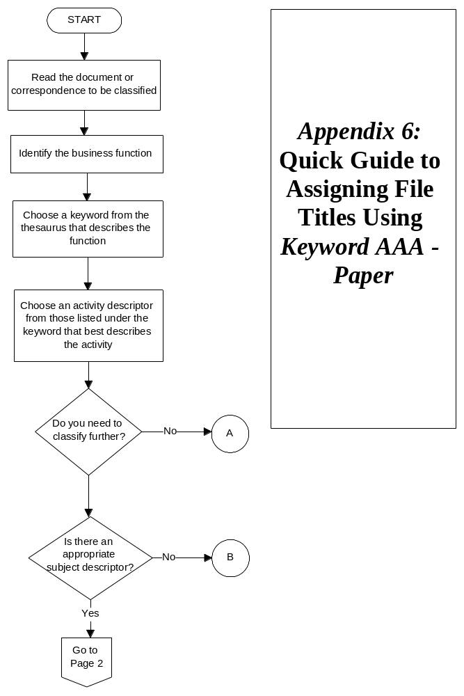
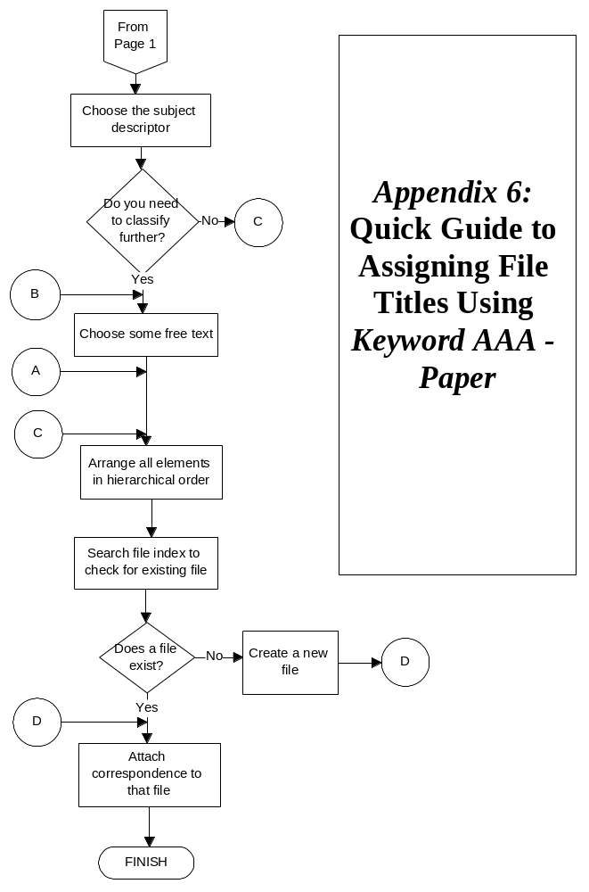
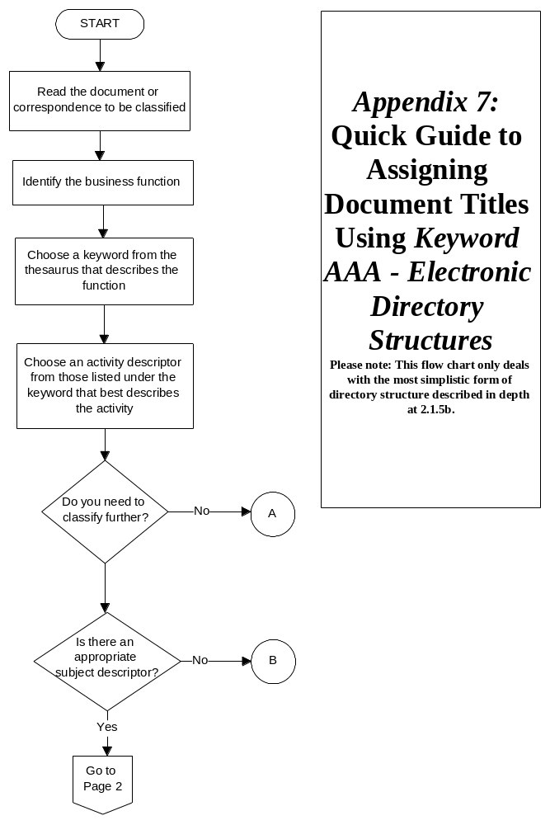
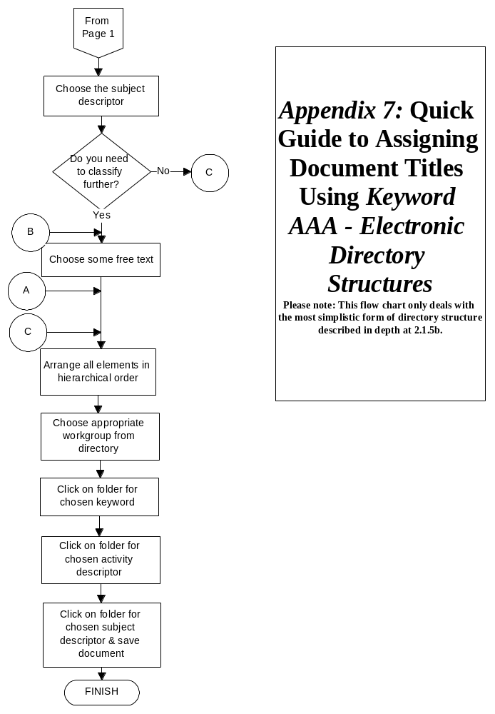
Appendix 8: Frequently Asked Questions

1 What is the advantage of functional approaches to classification over classification by subject?
The functional approach is a long term approach to records management. It is not only valuable for promoting retrieval (like subject-based thesauri), it can also be used to determine how long a record should be kept, how it should be handled and stored, and who should have access to it. The functional approach is also relevant for promoting continuum management in the electronic environment.
The functional approach is recommended by the Australian Standard AS 4390-1996, Records Management which strives to ensure that proper evidence is kept of business activities. See Section 1.2 in the Introduction.

2 Why can’t each division in the office have its own keyword?
The keywords in Keyword AAA are not based on structure. They are based on the functions of an organisation. The problems associated with arranging a classification scheme on structure are that:
- structures change regularly: organisations amalgamate, devolve, decentralise, and restructure, so you would have to continually change your classification scheme. Functions are more stable.
- structures are too rigid to handle the way business operates. Functions cut across organisational structures.
Occasionally, however, keywords will coincide with structural areas because they have been arranged according to function.

3 Is Keyword AAA able to be applied to all of the records of my agency?
No. Keyword AAA is a thesaurus of general terms, which are applicable to a wide range of agencies. You will also need to develop (or hire a consultant to develop) a functional thesaurus dealing with the terminology that is specific to your organisation. Keyword AAA and the functional thesaurus should then be merged together to achieve comprehensive coverage of all of your agency’s records. See Section 4.1.1 in the Introduction.
Additionally, not all records may need to have keyword titles. You may have some series of files that you wish to keep separate. For example, a series of case files is often easily arranged by the client’s surname and it would be unnecessarily complicated to assign keyword titles to these.

4 Why does the structure of file titles in Keyword AAA have to include keywords and activity descriptors in that order?
The order of a file title in Keyword AAA is imposed for a specific reason. It ensures that the title reflects the business classification scheme and that the function, activity and subject of the file are clearly represented. It is by having this imposed order that the other benefits of keyword classification like effective handling, storage and disposal, can be realised.

5 How can Keyword AAA be used for more than just file titling and indexing?
For information on how Keyword AAA can be used for other records management activities, see Section 1.3 the Introduction.

6 Why are subject descriptors limited in Keyword AAA and how can agencies avoid variations which may occur at this level?
Keyword AAA is currently being used at all three levels of government and by some private organisations. To include all subject descriptors required by these agencies, the thesaurus would be excessively large, completely unwieldy and impossible to use. It would also go out of date very quickly. Therefore, subject descriptors have been kept to a minimum.
In the process of developing your functional thesaurus to merge with Keyword AAA to achieve comprehensive coverage of your records, you may like to consider adding subject descriptors that are commonly used for titling in your agency. This will ensure that use of subject descriptors is consistent and retrieval is enhanced. See Section 4.1.2 in the Introduction.

7 What sort of documentation should agencies keep to establish consistency over procedures?
It is vital to ensure that you keep adequate documentation of the classification system in your agency.
We suggest, at the very least, you keep documentation of:
- the development of your functional thesaurus
- details of how you have changed terms in Keyword AAA when you have merged it with your functional thesaurus. This is particularly important because when you receive upgrades of Keyword AAA you will need to make the changes again. It is a good idea to code terms so you know which terms have been derived from your functional thesaurus and which from Keyword AAA
- versions of your merged thesaurus
- any procedures, rules or conventions you have established. For example:

Do you show names as:
John Smith
Smith John
J. Smith or
Smith J.?
You will also need to ensure the maintenance of links between:
- old files that do not use keyword classification, and new files that do
- files that are related to each other in a sequence.
You can do this by noting them on the file cover, linking them electronically, or noting them in the records management software.

8 How can Keyword AAA be used for Electronic Document Management (EDM)?
See section 2.1.5b for an explanation of how Keyword AAA can be applied to directory structures. Some document management software can also incorporate Keyword AAA.

9 How can resistance to the new classification scheme be overcome?
This is dependent on the reason for the resistance. Some possible causes may be that:
- there has not been enough communication and participation in the process of development and implementation
- there has not been enough marketing and training so staff do not understand why the thesaurus has been introduced, or how to use it
- there has not been enough leadership from sectional leaders, or endorsement from management
- there is a lack of quality control
- the thesaurus is somehow not meeting staff needs. Are they having difficulty finding a suitable title? Is this a fault of Keyword AAA or of functional terms? Are modifications necessary?
- staff resent needing more than one file on a topic - this may require some marketing of the benefits of functional classification
- the procedures for titling are not suiting staff. Are they having to undertake duties that they do not really understand? Is it taking too long to assign titles? Why? Can processes be streamlined?
You will need to isolate the cause of resistance and plan strategies to solve it where possible. For example, if there are terms missing that you think should be included in Keyword AAA contact State Records and see if they can be considered in the next review. If they are functional terms, note them for the review of your functional thesaurus. If the problems are caused by a lack of understanding of how to use Keyword AAA, you might consider holding briefings or training sessions, or sending key staff to courses run by State Records.
If you have any further questions regarding Keyword AAA please contact the State Records Authority of New South Wales.

